Fraction Action

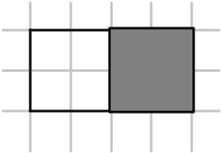Activity
Copy this diagram into your book three times.

- What fraction of the diagram is shaded? Label the first diagram with that fraction.
- Draw two lines on each of the remaining diagrams so that they are split into four equal pieces (quarters). What fraction of the diagrams are shaded now? Label your second diagram with this new fraction.
- Draw one more line on the final diagram so that it is split into eight equal pieces (eighths). Label the third diagram with the new fraction that now describes the shaded amount.

Big Fact One:

These three fractions must be equal to each other because the same amount is shaded in each diagram.
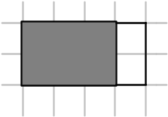
- Copy this diagram twice.
- Label the first with the fraction that is shaded.
- By adding one more line to the second diagram, find a fraction that is equal to the first.

Big Fact Two:
Fractions that are equal to each other are called equivalent fractions

Questions
- Draw diagrams to represent ²/₆ and ¹/₃.
Is it true that ²/₆ and ¹/₃ are equivalent fractions? Explain your answer.
- Draw diagrams to represent ³/₆ and ²/₄.
Is it true that ³/₆ and ²/₄ are equivalent fractions? Find another fraction that is equivalent to ³/₆.
- Draw diagrams to represent ³/₄ and ⁶/₁₀.
Is it true that ³/₄ and ⁶/₁₀ are equivalent fractions?
- Are ⁶/₈ and ³/₆ equivalent?

Time to Spare?
In the activity earlier, you found out that ½ = ²/₄, and that ½ = ⁴/₈. Can you see a pattern that connects these fractions? Write down your rule in words.
Use your rule or pattern to find the missing numbers in the following questions.
⁻ ³/₅ = ?/₁₀ - ³/₅ = ⁹/?
⁻ ²/₃ = ?/₉ - ¼ = ?/₁₂

- Find three fractions that are equivalent to ¾
- Find three fractions that are equivalent to ⁶/₁₂

